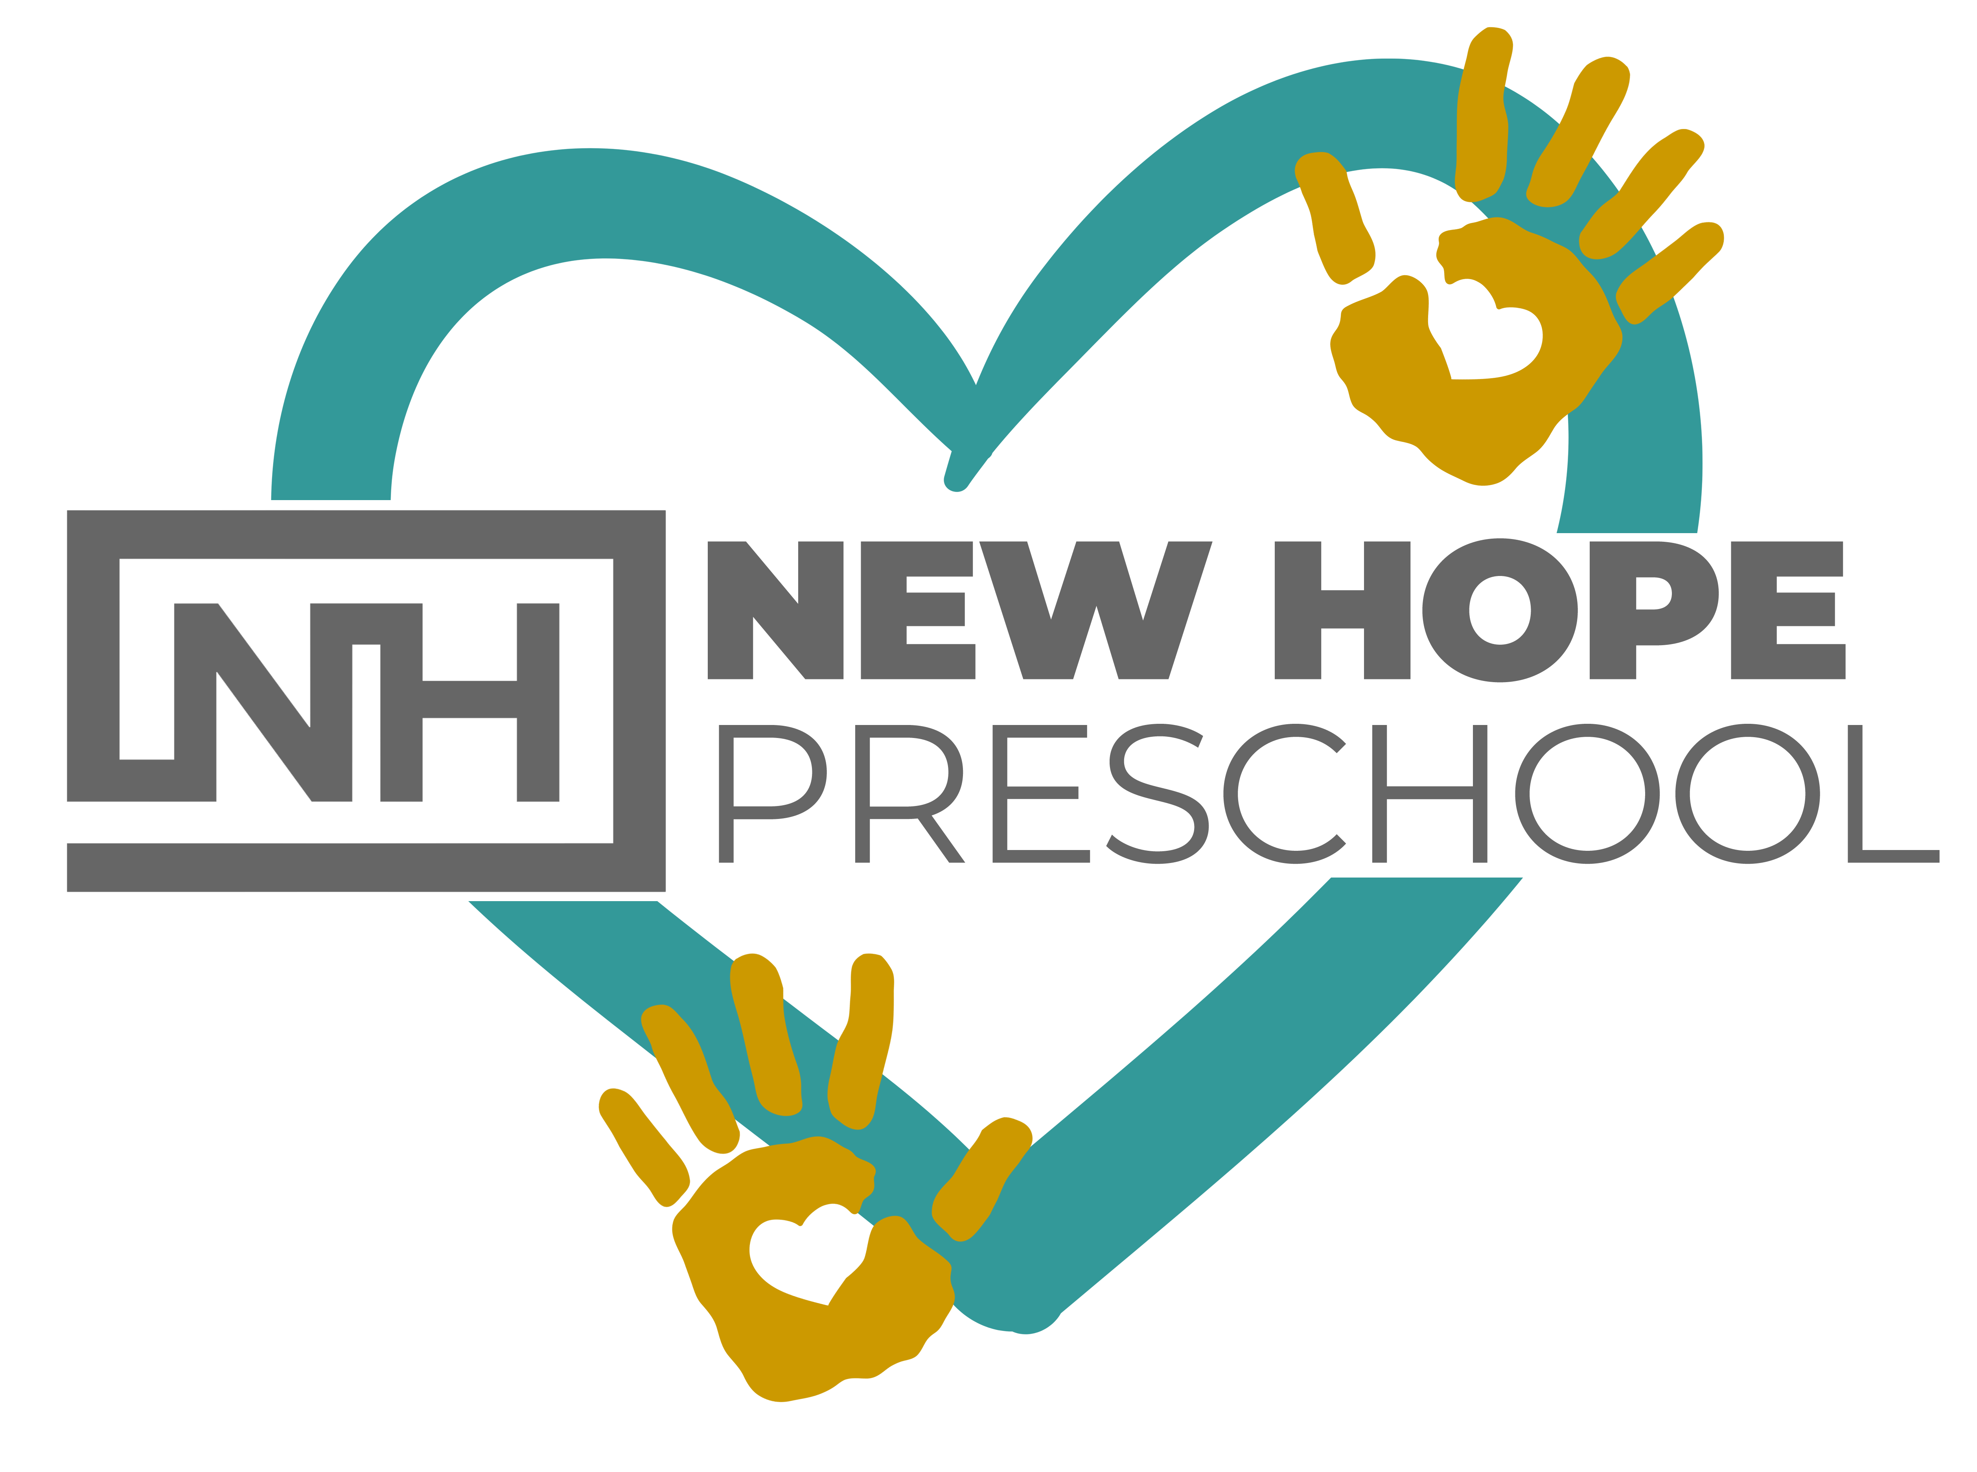

Parent Handbook
Covid-19 Edition

2020/21 School Year

New Hope Preschool
2720 Olympic Parkway
Chula Vista, CA 91915

Dear Parents,

As we get ready to reopen after being closed for more than 4 months, I want to make sure you are all aware of the guidelines that are in place as of today. I know this is unchartered territory for us all, but know that all the teachers and staff at New Hope Preschool are committed to providing a quality program that is safe and fun!

While many things will seem different with the new procedures in place, this will be for the safety of all. We will still be providing an environment that fosters fun and learning while keeping everyone safe.

This handbook will provide you with all the guidelines that are the “new normal” during the Covid 19 pandemic and will be in place until further notice. We will make sure that all changes are feasible for staff and children by following the CDC (Center for Disease Control) guidelines as well as those put forth by CCLD (Community Care Licensing Division)

Please feel free to contact me if you have any questions about the policies and procedures that are outline in this handbook. They are in place to ensure that New Hope Preschool is a safe and fun place for your families.

Partnering with you in passing on the heritage of faith to the next generation,

Tammy Marquez
New Hope Preschool Center Director
New Hope Community Church
619-600-4160 ext. 308
Tammy@go-newhope.com

Admission/Exclusion due to symptoms of illness

Children who are obviously ill with fever, diarrhea, vomiting, green-runny nose, puss/oozing eyes, disease or condition (i.e.- ringworm, head lice, chicken pox, measles, mumps, pink eye, fever over 100 degrees, etc.) will not be admitted to the program. It’s a danger to other children and staff members at our facility. If you have any doubts about your child’s health, please call us at 619-600-4160 ext. 308 to be sure they may attend. If your child appears to be sick or has any of the above while at school, we will notify the parent or guardian immediately, and it is necessary that the child be picked up within one hour of notification from NH Preschool.

The child will be permitted to return when his/her temperature is normal for 24 hours without the aid of fever reducing medication. Your child must not have any prescribed medication, such as antibiotics, in his/her system for at least 24 hours before returning. In the event your child is sent home with one of the above health concerns, they will not be permitted back to New Hope Preschool with out a doctor’s note. The doctor’s note must be written on their letterhead and read that the child can return to school because what they have is no longer contagious.

If a child is showing COVID-19 symptoms (fever, cough, shortness of breath) OR if you’ve been in close contact with a person or child testing positive for COVID-19, we ask you to keep your child home. They must be isolated for a minimum of 7 days after symptoms onset, and 72 hours after their fever resolves without fever-reducing medicine. (For example, if symptoms and fever resolve on day 7, the person can return on day 10.) For most, this will be 14 days after the household contact with COVID-19.

We ask that all parents and staff let us know of any potential exposure immediately. A potential exposure means being a household contact or having close contact within 6 feet of an individual with confirmed or suspected COVID- 19 for at least 10 minutes. The time frame for having contact with an individual includes the period of 48 hours before the individual became systematic. If in the childcare center, we will inform CCLD and our parents along with the Department of Health (DOH).

Extra Hygiene Measures and Procedures:

Hand washing: As soon as a student arrives to the classroom, they will wash their hands properly. Every faucet handle will be sanitized with each use. Hands will also be washed throughout the day and more frequently with soap and water for at least 20 seconds. Hand sanitizer will be used when soap and water is not available (teachers will dispense and then place in a cabinet).

Sanitizing/Disinfecting: All hard surfaces will be wiped down throughout the day, before and after use as well as at the end of each day. Any toys that go into a child’s mouth will be put into the disinfecting process like usual. All surfaces and toys will be sprayed prior to leaving the room throughout the day. All sensory bins, soft toys, pillows, dress up clothes will be put away during this phase of opening.

Mask Wearing: Each enrolled student will need two masks that they will use while here at New Hope Preschool. Masks will be kept here in the facility and taken home by the families to be laundered at the end of each week. If you are in need of a mask, please email the director.
It will be mandatory for all teachers to wear a mask.

Social Distancing: Each class is considered a “family.” Each “family” will social distance from other “families” to assure safety. Children will not need to wear a mask when they are in their “home” (classroom), on the playground during their designated time, or in the bathroom. Classes will not intermix and will be with the same teachers as much as possible. When staff and children leave the classroom they will be encouraged to wear their mask to the best of their ability until they get to their destination. Once they reach their destination, masks will be removed and placed in an individual container/bag. All church staff will wear masks when not in their personal office/cubicle.

Socks-only classroom: All children will take shoes off before entering the classroom. Shoes will be placed in the hallway. Teachers will be allowed to bring in “indoor shoes” to wear in the classroom only. Since children spend time on the floor, we want it to be as clean as safe as possible.

Personal Belongings

While in this phase of operation, children may not bring in any personal belongings aside from what is approved. No toys or personal items from home will be permitted at this time. All fabric masks will stay here on the premises and go home on the child’s last day to be laundered before returning the following week.

Arrival and Departure Procedures

Our facility is operational from 9am-12pm or 9am-2pm Monday through Thursday. While operating in this phase, drop-off times will be staggered. You will be given a time between 9am-10am to drop off and an hour time frame to pick up. All children must be dropped off by 10am. Please only come at your designated drop-off or pick up time to keep everyone safe. If you see another family being checked in, please be patient during this time.

Drop Off Procedures:

Drop off times will be staggered to allow for safe social distancing.
The check in staff will do a visual assessment and then ask a series of yes/no questions regarding symptoms and travel. Your child will have their temperature taken. If it is below 100F, the check in staff will take your child to his/her classroom, and be given their cloth mask (provided/laundered by you) that he/she is recommended to wear to the best of their ability while walking to their classroom. Once in the classroom, the mask will be placed safely in a bag specific to each child.

We ask that the designated drop-off and pick-up person not be a “vulnerable” person (older person such as grandparent or person with a serious underlying medical condition).

Pick Up Procedures:

Pick up times will be staggered to allow for safe social distancing. Please abide by the assigned pick up time. If you see any other family being helped, please be patient until it is your turn.

Visitors

Visitors will not be permitted at this time.

Parties and Celebrations

Birthdays- if you wish to celebrate your child’s birthday at New Hope Preschool, please check with your child’s teacher at least one week in advance with what your plans will be for that celebration. Children may only distribute pre-packaged treats as opposed to homemade. The use of candles is prohibited due to safety reasons. Note: All birthday treats must be nut free and from this approved list: mini-cupcakes, donut holes, mini muffins, ice pops, prepackaged treats.

School Supply List: (Please Label Everything). Please bring all items on your child’s first day back.

For the classroom:
3 Bottles of hand soap
3 Boxes of tissue
2 Containers of Lysol/Clorox Wipes

For your child:
Extra change of clothes (including socks)
Water bottle
Pencil Box containing these items-
Small box of crayons
Scissors (kids scissors, blunt tip)
Glue Sticks
My First Ticonderoga Pencils
Eraser
Markers

